Create a windows form application, named StudentNumberMT (ie. 123123123MT).  Your solution, project, and main form should share this name as appropriate.  The completed question must be zipped into a folder of the same name (123123123MT for example), so that when I extract it I get a new folder created, and inside that folder is your sln file and a folder with your project. Failure for this to work, and be appropriately tested before submission will result in a zero in the worst case.

You are to create a form that calculates the total cost of a hotel stay as seen below:

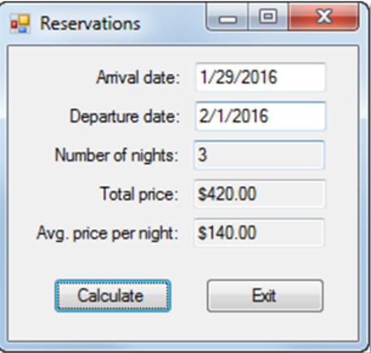

Weekend Nights (Friday & Saturday night) should be billed at $210

Weekday nights (the rest) should be billed at $159

The first two fields should be date picker controls allowing the user a convienient means of selecting dates.

Ensure the price & average price fields are formated as a currency, and displayed with 2 digits of precision.

upon clicking the "Calculate" button, a message box should be displayed which summarizes the charges as follows:

"Your total is $420.00 for 2 nights beginning Friday, October 26, 2018.  Please enjoy your stay!"

Input should be validated, and checked for reasonable values, overflows, etc, avoid relying on try catch if at all possible (hint: it probably is!)

Please review the rubric before beginning, and ensure correct submission.